Motion

Linear, angular, and general motion

**Linear motion:**

motion along a line, either straight or curvilinear. Takes place when a body moves so that all parts of it travel exactly the same distance, in the same direction at the same time.

* Distance: path the body moves from one point to another. Not necessarily in a direct straight line. Described/measured in terms of magnitude.
* Displacement: found by measuring the distance of a straight line joining the body’s initial and final positions
* Speed: distance covered/time taken
* Velocity: displacement/time taken. Speed in given direction, the rate at which a body moves, measured in m/s.
* Acceleration: change in velocity (final velocity-initial velocity/time)
  + Increase in velocity = positive acceleration
  + Positive acceleration continues until the body reaches maximum speed.
  + There is an acceleration of zero while velocity is maintained.

**Angular motion:**

takes place when a body moves around an axis of rotation:

* Internal axis: axis passes through the body.
* External axis: axis outside of the body, generally something we are hanging onto.
* All parts move about the same direction, angle, and time.
* This is rotary, circular motion, also known as rotation.

Rotation of the stick in a hockey drive is an example of angular motion.

**Angular kinematics:**

* Angular distance: the sum of all angles that the body moves through its initial to its final position.
* Angular displacement: the angle between the initial and final position on the body
* Angular velocity: angular distance/time taken.
* Angular acceleration: the rate at which the angular velocity of a body changes with respect to time = final velocity-initial velocity/time

**General motion:**

both linear and angular motion. The most common form of motion in sport is cycling = translation/linear motion of the upper body and the rotation of the thigh about the axis of the hip joint. Leg around the knee joint and foot around the ankle joint

Projectile motion

Optimal projection, parabolic trajectory, release of projectiles

**Projectile motion:**

a body that is released into the air and becomes a projectile. Throwing a discus, softball, lacrosse, striking tennis, football, cricket, projecting the body in diving, jumping, gymnastics

**Factors governing the behavior of projectiles:**

* Trajectory: the path a body follows through the air
  + Gravity acts to change the motion of the projectile.
  + It combines horizontal motion/velocity and vertical motion/velocity.
* Horizontal component (motion/velocity): acts parallel to the ground.
  + No tendency to lift the object into the air.
  + The distance and the rate of movement at which the body/projectile is going out.
  + Projectiles maintain the same horizontal velocity throughout its flight. Only air resistance and gravity will change its state of motion.
* Vertical component (motion/velocity): the rate of movement in which the body is going up.
  + Vertical velocity determines the height of the apex therefore affecting the height of the projectile reaches and the time it takes to reach it and return to the landing point.
  + Imparted on the body at the time of release/take off, responsible for lifting of the body into the air.
  + Vertical height and the time of the flight are determined by the vertical velocity at release/take off.
  + Time in flight = time taken for the body to reach its peak + time taken for it to land.

**Factors affecting projectile motion:**

* Velocity at release
  + Has the greatest influence. It will determine the height and the length of the trajectory (when all factors are constant)
  + The greater the initial vertical velocity the greater the flight time and the greater the height reached.
  + The greater the initial horizontal velocity the greater the horizontal distance
* Heigh of release:
  + The projectile is release and lands at the same level: optimum angle is 45.
  + The projectile is released from a higher position than the landing point: the optimum angle of release is less than 45.
  + The projectile is released from a position lower than the landing point: the optimum angle is of release is greater than 45.
* Angle of release:
  + The lower the angle of release the faster the projectile will reach its destination.

Newtons Laws

Newtons Laws and how they apply to sporting context

**Newtons First law of motion: Inertia**

A body remains at rest or in uniform motion in a straight line unless acted upon by another force.

* The inertia of an object is directly proportional to its mass.
* The size or magnitude of the force applied to change the state of motion of the body will depend on the body’s mass or inertia.
* The larger the mass to be moved or changed the greater the force required to bring about a change in motion.
* The magnitude of the force is directly proportional to the mass of the body.
* Example: Newtons first law of motion in relation to 100m freestyle:
  + Swimmer waiting on the blocks, internally contracts muscles to create motion off the block.
* Example in relation to dig in volleyball:
  + The volleyball is in flight and therefore, has motion. An external force is applied by the player to the ball. This results in a change in motion.

**Newtons Second law of motion: Acceleration**

When a body is acted upon by a force, its resulting change in momentum is proportional to the force causing it. It is proportional to the mass; the change takes place in the direction in which the force is applied.

* The greater the force, the acceleration.
* The smaller the mass, the greater the acceleration.
* The change in motion takes place in the direction which the force is applied.
* For a constant mass (netball) the greater the force applied, the greater acceleration.
* Momentum (p): amount of motion possessed by a moving object.
* Momentum (p) = mass (m) x velocity (v)
* Impulse = force x time
* The heavier the bat in baseball the greater the chance of hitting the ball far, providing you can still swing the bat with the same velocity
* Force absorption:
  + Large forces must be absorbed by the body on landing following a catch.
  + Important to absorb these forced in the most appropriate way when landing.
  + Decreasing the time over which the force is absorbed leads to a greater risk of injury

**Newtons Third law of motion: Action-Reaction**

For every action there is an equal and opposite reaction

* A force acting anywhere always has a force equal to that acting in the opposite direction.
* Forces work in pairs opposing one another.
* The initial force (action force) is opposed by a second force (reactive force)
* When a runner pushes against the ground a downward and backward force against the ground occurs (action force), at the same time the ground exerts the same (equal) force upwards and forwards – in the same direction, resulting in runner moving forward

Balance

Definition of the principle of balance and how it applies to sport

*Content that follows:*

* *Centre/line of gravity*
* *Width of base of support*
* *Height of centre of gravity*
* *Types of balance (static and dynamic)*

**Body weight:**

is a combination of body mass, which doesn’t change, and the force of gravity, which there might be small changes depending on the location.

**Centre of gravity:**

the point at which the weight of the object is balanced, it is an imaginary point, and it does not have to be within the body. It is not a fixed point

**Balance:**

the position of the centre of gravity has important implications in the concept of balance. Balance is an objects resistance to movement, either linear or angular, from a balanced position

**Types of balance:**

* Static: when an object is at rest and is not moving with linear or angular motion, it \\said to be in a state of static balance. This is in sports such as archery.
* Dynamic: when an object is in motion, in team sports like squash. Require a lower centre of gravity, line of centre of gravity is near the edge of the base of support.

**Factors influencing balance:**

* Mass: the greater the mass of an object, the greater the stability
* Base of support: feet shoulder width apart for optimal balance, narrow base reduces balance and wide stance makes movement difficult
* Line of centre of gravity: should be central for optimal balance, at the edge of the base of support for quick movement

**Factors affecting stability of object:**

* The height of the centre of gravity of the object above the base of support: the higher the centre of gravity above the base of support, the less stable the object is.
* The position of the line of gravity relative to the base of support: the line of gravity is an imaginary vertical line passing downwards through the centre of gravity. The close the line of gravity is to the limits of base of support, the less stable the degree of stability of object

The coordination of linear motion

Sequential and Simultaneous movement

**The coordination continuum**

Coordination is commonly defined as the sequence and timing of body actions used in a movement. The principle suggests that high force movement use more simultaneous joint rotations while low force and high-speed movement use more sequential joint rotations. The kinematic timing of segment motions falls on a coordination continuum from simultaneous to sequential movement.

**Sequential movement**

Used to generate maximum force/velocity – segments are in sequence

* Allows a projectile to be released at the greatest possible velocity through maximising the speed of the body, racquet, club etc
* Accomplished through sequential movement: body parts involved move in sequence beginning with the body segments that are the
  + Largest, strongest and have the greatest inertia
  + Works through the smallest and fastest segments
* The greatest amounts of momentum/force are transferred progressively from the largest body parts to the smallest. Done through a way when the next body segments begin to move when the previous segments have reached its maximum speed/velocity

**5 Points to remember:**

1. Whenever a sequence of movement is used to produce optimal velocity, then each segment should be moved at the instant previous segment begins to slow down
2. The velocity of a projectile is dependent on the speed of the last part of the body/sequence at the time of contact or release
3. When maximal force is desired (javelin throw/cricket bowling) as many body parts as possible should be used
4. It is important that sequential stabilisation occurs at each body segment so that the next segment accelerates around a stable base to gain maximal force
5. Important of the follow through; ensures there is no deceleration of the final segments, follow through

**Simultaneous movement**

Some sporting actions require body parts to contribute force explosively at the same time: explosive movements, force exerted at once, for accuracy (segments move as one)

Examples: high jump take off, basketball chest pass, breaststroke leg kick

* Several actions occur simultaneously to contribute to the force of the basketball pass: step in the required direction, rear leg push, trunk flexion, arm extension, wrist flexion

Functional anatomy

Use of musculoskeletal structures in the production of movement

**Skeletal function:**

the human skeleton is called the endoskeleton because it is found beneath the skim, it supports the body structure:

* Protects internal organs.
* Area of red blood cell development
* Storage of nutrients
* Framework from which movement is derived.

**Body movement:**

results of muscles contracting against the rigid skeletal structure, the type of movement is determined by:

* Structure of bone
* Placement of ligaments
* Attachments points of muscle.
* Muscle flexibility
* Size of the bone

**Movement:**

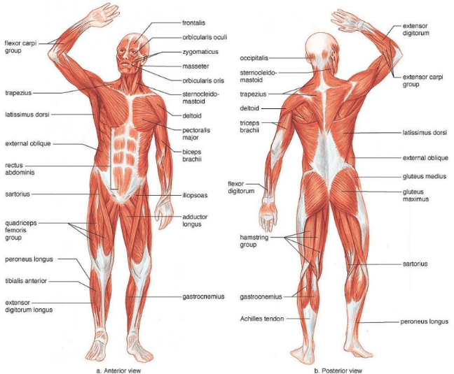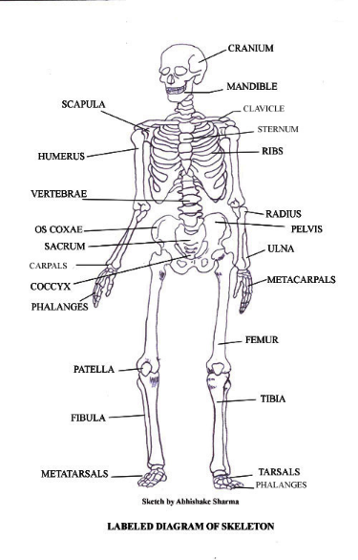the joints between bones allow movement. The range of movement of these joints may be reduced or enhance by a number of factors including:

* Structure of the bone
* Type of joint it forms.
* Muscles attachment points
* Muscle size
* Flexibility

**Bones and muscles:**

Bones: humerus, radius, ulna, femur, patella, tibia, fibula, pelvis, sternum, ribs, carpals, metacarpals, phalanges, tarsals, metatarsals. Muscles: bicep, triceps, gastrocnemius, trapezius, deltoid, quadriceps, hamstrings, tibialis anterior, adductor group, latissimus dorsi, soleus, abdominal, gluteus maximus, pectorals

**Muscle fiber types:**

Fast twitch fibres (Type II): linked to muscles involved in quicker, more explosive movements. Sprinters have a high percentage of fast twitch fibres:

* White in colour
* Rapid contraction speed
* High capacity for anaerobic ATP production
* Larger than slow twitch fibres, generate greater force and more powerful contractions, easily fatigue

Slow twitch fibres (Type I): found in muscles related to posture, they are more fatigue resistant, and athletes involved in endurance events have a high percentage of slow twitch fibres:

* Red in colour
* Generate energy mainly through aerobics pathway.
* Contract repeatedly for prolonged periods but slowly
* Require steady state of aerobic energy.

**Muscle characteristics:**

* Contractile: shortens when developing tension
* Extensibility: being able to stretch muscle beyond its normal resting length
* Excitability: ability to receive and respond to stimuli
* Elasticity: returning to original shape after being stretched

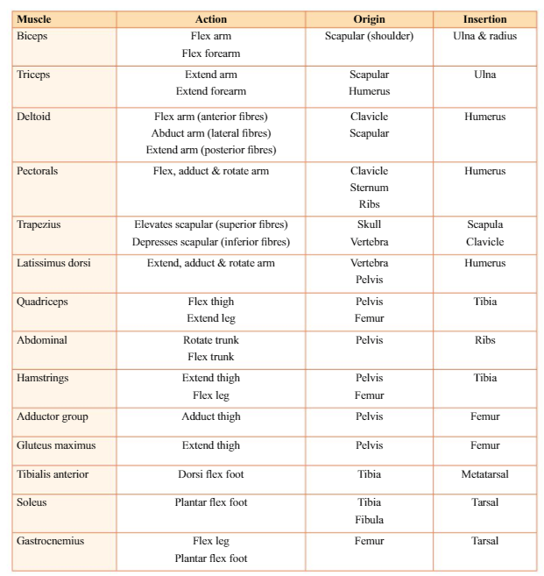**Muscle contractions:**

* Concentric muscle contractions: muscle shortens when tension is developed.
* Eccentric muscle contractions: muscle lengthens when tension is developed.
* Isometric muscle contractions: no change in length when tension is developed.

**Joint movement:**

* agonist: prime muscle that is responsible for movement.
* antagonist: muscle that creates the opposite movement that agonist makes.
* Origin: attached to the most stable bone
* Insertion: attaches to the bone that moves when muscle contracts

**movement types created by muscle action and joint movement:**

* Flexion: joint angle is decreased, and limbs move closer together
* Extension: joint angle increased, and limbs move further apart
* Circumduction: when the limbs move in a circle, occurs at shoulder join e.g. tennis serve
* Rotation: when the limb turns around its long axis e.g. turning head side to side
* Supination: when the palm is facing up
* Pronation: palm facing down (movements that occur at the proximal radioulnar joint)
* Adduction: the movement towards the midline, brings hands down to side of body
* Abduction: movement away from the midline, shoulder raises arms out to side
* Dorsi Flexion: pulling toes toward you.

The respiratory system

Structure and function of the respiratory system

*Content that follows:*

* *Pulmonary ventilation*
* *Mechanics of breathing*
* *Minute ventilation, tidal volume and breathing rate*
* *Gas exchange in the lungs*

**Systems:**

Fundamental to the aerobic system is amount of oxygen consumed by the body. Respiratory system brings oxygen from surrounding into lungs, then moved into blood and transported by the cardiovascular system to the muscles

**Pulmonary ventilation:**

Process by which oxygen to support the aerobic system, the respiratory system must transport oxygen from outside to lungs.

* Air enters through mouth/nose and travels through the trachea to lungs
* Trachea branches into bronchi/bronchioles which become alveoli
* The gas moves in and out of the bloodstream
* Transfer of gases between alveoli and bloodstream = gas exchange

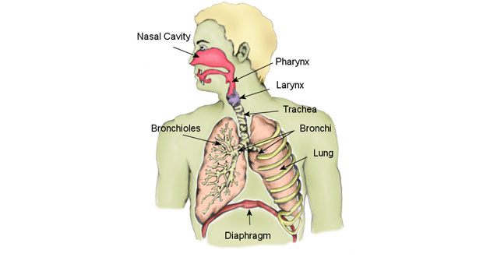**Mechanics of breathing:**

Complex processes result in inspiration of air. Diaphragm plays important role.

* Diaphragm: dome shaped sheet of muscle that separates thoracic cavity, containing lungs and heart
  + Inspiration: occurs when diaphragm contracts and moves downwards toward the abdominal cavity (dome flattens), causes space for lungs to expand, low air pressure within lungs
  + Expiration: predominantly passive, air is being forced out as diaphragm relaxes and rise back toward the thorax

**Minute ventilation:**

The amount of air we inspire each minute, in L. determined by the amount of air we inspire each breath (tidal volume) x breathing rate

**Gas exchange in the lungs:**

Air we breathe is mixture of gases (nitrogen, carbon dioxide and oxygen)

* Gas exchange occurs by passive diffusion, moving from high concentration to low concentration in order to reach equilibrium
* Gas naturally spreads out evenly in the environment
* Oxygen moves from alveoli to blood; carbon dioxide moves from blood into alveoli to be expelled from the body upon expiration

The cardiovascular system

The structure and function of the cardiovascular system

*Content that follows:*

* *Pulmonary and systemic circulation*
* *Heart rate, stroke volume, cardiac output*
* *Blood vessels: arteries, capillaries, and veins*
* *Blood pressure: systolic and diastolic*

Central to the cardiovascular system, located between lungs, divided into four chambers. Top chamber is atria (receives blood from circulation) and the bottom two ventricles (pump blood out into circulation)

**Pulmonary and systemic circulation:**

Heart consists of two separates pumps that serves different pathways.

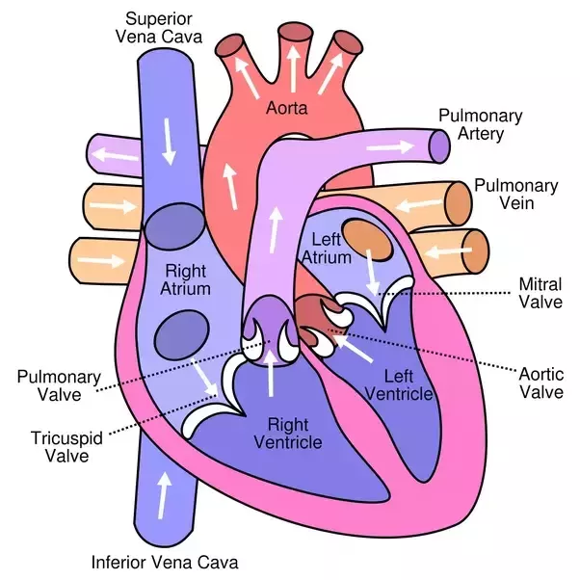Pulmonary circulation:

* Blood is received into right atrium from body via vena cava
* This blood is low in oxygen and high in carbon dioxide
* Pumped from the right atrium into right ventricle and pumped to lungs via the pulmonary arteries
* Oxygenated blood then transported from the lungs back to the left side of the heart via pulmonary veins
* Then enters the left atrium, then ventricle below to be pumped into system circuit via aorta

Systemic circulation:

* Has a lot further to travel (around the whole body)

**Heart rate/stroke volume/cardiac output:**

Heart rate: beats around seventy times/minute, varies depending on individuals

Stroke volume: Relates to the volume of blood pumped with each beat of the heart

Cardiac output: word used to describe the amount of blood ejected by the heart each minute

CARDIAC OUTPUT = STROKE VOLUME X HEART RATE

**Blood vessels:**

* Arteries: transport blood away from the heart. Blood pressure lower further from
* Capillaries: site of gas exchange. One cell thick wall, clusters (capillary networks)
* Veins: transport blood back to the heart. Pressure of the heartbeat is too low in the veins to push the blood back into the heart in many ways: skeletal pump, semilunar valves, inspiration, gravity.

**Blood pressure:**

Pressure that is exerted on the blood vessel walls as blood is pumped from the left ventricle into the arterial system, this pressure moves the blood through the blood vessels to the smaller capillaries.

* Systolic: it is the highest pressure at any one time, during the heart’s contraction
* Diastolic: the lowest pressure exerted on the artery walls, occurs when the heart relaxes to refill with blood

Macro nutrients

Utilisation of carbs, fats, proteins for physical activity

*Content that follows:*

* *Energy released from food*
* *Carbohydrates: glucose, glycogen, and glycaemic index*
* *Fat: free fatty acids, saturated triglycerides*
* *Proteins: amino acids*
* *Energy requirements for physical activity*

**Energy for physical activity:**

ATP (adenosine triphosphate) is the basic unit of energy that fuels all of the activities that we participate in throughout the day. A molecule of one adenosine component attached to three phosphate group.

* 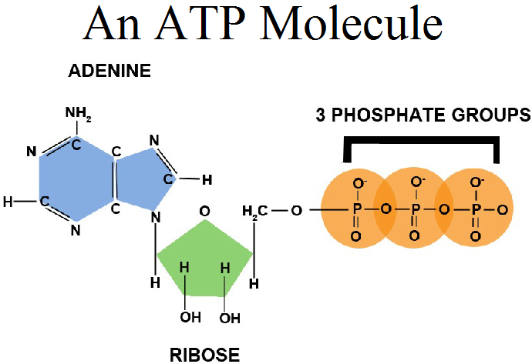The amount of ATP in the body is small and must be constantly regenerated
* ATP is continually resynthesised from energy released from stored macronutrients
* The amount of each macronutrient required in the diet varies

**Carbohydrates:**

What happens when we ingest carbohydrates?

* First converted to blood glucose
* Excess blood glucose is converted to glycogen
* Glycogen is stored for future use in the muscle and liver

A diet deficient in carbohydrates rapidly results in depleted muscle and liver glycogen stores. High glycaemic index carbohydrates release blood quickly into the blood stream e.g. lollies. Low glycaemic index releases them slowly into the blood e.g. cereal.

**Lipids (fats):**

Represents the body’s most plentiful source of potential energy

* Takes too long to break down
* Is an inefficient fuel source, predominantly uses carbohydrates
* Fats are major energy source during rest and light exercise, not during intense exercise because it must be reduced to triglyceride to its basic components (glycerol and fatty acids) and this process is too slow to supply fuel during intense exercise

**Proteins:**

Used to produce ATP only under extreme conditions e.g. marathons. Simplest unit is called amino acids

Energy systems

Response of energy systems to physical activity

*Content that follows:*

* *ATP-CP system/Lactic acid system/Aerobic energy system*
* *Comparing the energy systems/relationship between energy systems*
* *Commencement of exercise*
* *Oxygen deficit*

**ATP-CP System:**

Also known as the phosphagen system, what is it:

* Provides the most rapid source of ATP but is limited in the amount of ATP that is produced
* We only store CP to power about 8 seconds of intense activity
* It is the dominant source of energy production during short sprint activities

How does it work:

1. The ATP-CP system used a stored molecule in the muscle called creatin phosphate to resynthesise ATP
2. It is the breakdown of this molecule that releases the energy needed to join the ADP and free phosphate to form ATP
3. This system is anaerobic as it works without oxygen

**Lactic Acid System:**

The lactic acid system (anerobic glycolysis) involves the partial breakdown of carbohydrate to lactic acid, which release the energy to make up ATP

* The fuel source is carbohydrates
* It does not require oxygen which makes it anaerobic
* Speed of the energy supply is rapid but not as fast as ATP-CP
* The limitation is the production of lactic acid
* Mainly used in sprint endurance events like the 400m sprint

**Aerobic System:**

The aerobic energy system is used for around 1.5 – 3 hours into a sporting activity

* The fuel source for this energy system ae carbohydrates (used first) and fats (used after carbohydrates run out) and proteins (after carbohydrates and fats)
* Oxygen is required for this system. The speed of energy supply is slow
* There is no limitation to this energy system, as long as you have the fuel to sustain it
* Used in distance swimming, triathlons and marathon running

**Relationship between energy systems:**

All three energy systems operate at once, with the intensity and duration of the activity determining the percentage contribution of each different system.

**Oxygen deficit:**

When commencing exercise, takes time for oxygen consumption to increase, results in an oxygen deficit that must be repaid post-exercise.

Immediate responses to exercise

Explain the body’s immediate response to physical activity

*Content that follows:*

* *Tidal volume*
* *Respiratory rate*
* *Minute ventilation*
* *Gas exchange in the lungs*
* *Heart rate*
* *Stroke volume*
* *Cardiac output*
* *Gas exchange in the tissues*
* *Blood pressure*
* *Blood redistribution*
* *Oxygen consumption*

The body responds to the commencement of exercise by increasing all the processes involved in transporting oxygen to the working muscle

**Minute ventilation**

Due to an increase in both tidal volume and the number of breaths per minute the minute ventilation increases

**Cardiac output**

Due to an increase in both heart rate and stroke volume the cardiac output increases

**Blood pressure**

* Increased systolic blood pressure in direct proportion to exercise intensity
* Diastolic blood pressure remains relatively stable

**Blood redistribution**

Blood is rapidly redistributed to the working muscles with the onset of exercise

**Oxygen consumption**

Oxygen consumption increases in direct proportion to exercise intensity, until a maximum is reached

* Steady state oxygen consumption: when the oxygen consumption has increased enough to meet the demands of the working muscles and is sufficient level to provide adequate ATP production via the aerobic energy system

The lactate threshold is the exercise intensity at which lactic acid begins to accumulate in the blood

Oxygen consumption may remain elevated for hours after exercise

* EPOC: excess post oxygen consumption
* Oxygen debt: replaced depleted oxygen stores in the body, supply oxygen to the active heart and respiratory muscles, supply oxygen to the body tissues due to increased temperatures

Long term adaptations to training

Explain the body’s long-term adaptations to training

*Content that follows:*

* *Ventilation*
* *Gas exchange at the lungs*
* *Heart rate/stroke volume/cardiac output*
* *Blood volume and haemoglobin*
* *Gas exchange at the tissues*
* *Oxygen consumption*

Regular exercise training results in cardiorespiratory adaptations that improve exercise performance

* Central adaptations: within the cardiorespiratory system
* Peripheral adaptations: within the muscle itself

**Respiratory adaptations:**

* Minimal effect on lung structure and function
* More efficient respiration
* Higher maximal minute ventilation as a result of increased breathing frequency and maximal tidal volume
* Increased rate of oxygen exchange at the lungs

**Cardiovascular adaptations:**

* Heart rate: Lower resting heart rate response to submaximal exercise. No effect on maximal heart rate
* Stroke volume: Increased resting stroke volume during exercise
* Cardiac output: Unchanged at rest (due to higher stroke volume but lower resting heart rate). Increased during maximal exercise (due to higher stroke volume but same maximal heart rate)
* Blood volume and haemoglobin: Increased total blood volume and haemoglobin
* Gas exchange at the tissues: Improved oxygen exchange at the tissues due to the increased capillarisation
* Oxygen consumption: Quicker attainment of steady state oxygen consumption (and therefore a smaller oxygen deficit). Increased maximal oxygen consumption

**Metabolic adaptations:**

* Increased fuel storage within the muscle
* Increased number and size of mitochondria for the aerobic energy system
* Increased levels of enzymes involved in the production of ATP

**Chronic adaptations:**

the central and peripheral adaptations to training result in improved exercise performance as a result of enhanced:

* Aerobic capacity:
  + Highest amount of ATP that can be produced by the aerobic energy system
* Anaerobic capacity:
  + Highest amount of ATP that can be produced by anaerobic pathways
  + A combination of both aerobic and anaerobic capacity

Components of fitness

Explain the components of fitness

**Health related components:**

* Cardiorespiratory endurance: Cardiorespiratory endurance relates to the ability of the respiratory and circulatory systems to supply oxygen to the working muscle during exercise
* Muscular strength: Muscular strength is the ability to exert force in a single maximal effort
* Muscular endurance: The ability to perform repeated submaximal contractions without undue fatigue
* Flexibility: The range of motion about a joint
* Body composition: Relates to the proportion of fat and lean muscle mass in the body

**Skill related components:**

* Agility: the ability to rapidly change direction
* Balance: the ability to maintain stability while in motion
* Coordination: the ability to integrate the senses and movement of body parts to perform tasks
* Reaction time: the time taken from when a stimulus is presented to when the appropriate reaction is taken
* Speed: the ability to perform a movement quickly
* Power: the ability to perform a strong movement quickly

**Principles of training:**

The way in which the body responds to exercise training depends on the type of training undertaken. –

* This is the principle of specificity of training.
* Progressive overload must be applied to achieve training adaptations
* Progressive overload can be applied by increasing intensity, duration, or frequency of exercise
* Adaptations to training are not permanent and can be lost with detraining
* This is the principle of reversibility of training

**Types of training:**

* Continuous training: involves exercise in continuous fashion for a prolonged period of time
* Cross training: involves an alternative mode/s of exercise to the one that an athlete is training for
* Fartlek: method of continuous training involving variations in pace between periods of harder work and periods of easier work for relief
* Interval training: involves repeated bouts of work, alternated with periods of recovery. Intervals can be aerobic or anaerobic in nature
* Resistance: stimulates the body to adapt to coping with heavier loads. By changing the load, number of set, reps, and the speed of motion, we can change the focus from enhancing muscular strength, power, or endurance.
* Circuit training: typically involves performing as many repetitions as possible in a given period of time. Generally the exercises involved are set up in a circular fashion, athletes move from stations
* Flexibility: may be improved by static stretching, PNF stretching, ballistic stretching.
* Plyometrics: form of resistance training that uses the weight of the body to apply resistance in dynamic activities such as jumping

Skill classification

**Motor learning and coaching**

**Highly skilled performers are:**

* Faster
* More consistent
* Able to display greater control and timing
* More physiologically efficient
* Make correct decisions

**Motor skill:**

The learned ability to bring about a predetermined results with maximum certainty and minimum time and energy or both

**Perceptual skill:**

The process of recognising and then interpreting information from the environment

**Cognitive skill:**

The mental processing that incorporates problem solving, remembering and decision making

**Examples of motor/perceptual/cognitive skills in sport:**

* Tennis
  + Motor skill: tennis serve aimed at the middle of the T of the service box
  + Perceptual skill: viewing and judging the width and depth of where my opponent is standing when returning my serve
  + Cognitive skill: remembering that my opponent has trouble returning the ball when served to their backhand and deciding to serve to that side
* Soccer
  + Motor skill: goalkeeper trying to save a penalty kick
  + Perceptual skill: keeping my gaze focused on the hips and trunk of the kicker
  + Cognitive skill: deciding to dive to the right before the ball is kicked because of the angle of the hips and trunk of the kicker

**Motor learning v motor performance:**

Motor learning: a relatively permanent change in motor skills capabilities that is associated with practice

* Inferred from performance
* Relatively permanent
* Due to practice

Motor performance: an observable behaviour at a specific time and location

* Observable behaviour
* Temporary
* May not be due to practice

**Closed and open skills:**

Closed skills:

* The performer dictates the timing of the skill
* The environment is predictable and stable
* E.g. serving in tennis, throwing a dart, lawn bowling

Open skills:

* The timing of the skill is dictated by factors external to the performer
* The environment is unpredictable or unstable
* E.g. surfing, returning a serve in tennis

**Fine and gross skills:**

Fine skills:

* Use controlled movement of small muscles
* E.g. typing, pistol shooting, writing

Gross skills:

* Use large muscles
* E.g. walking, running, kicking a football

**Discrete/serial/continuous skills:**

Discrete skills:

* Identifiable start and finish
* E.g. serving in tennis

Continuous skills:

* no distinct beginning and end points and contain repetitive movements
* e.g. running, swimming

Serial skills:

* sequence of discrete skills together to form more complicated skills
* e.g. dance routine

**Simple and complex skills:**

The complexity of a motor skills is defined by:

* the amount of information to be processed
* the required level of movement precision or accuracy
* the time available to process information perceptually and cognitively

Simple skills:

* throwing a dart
* shooting an arrow

Complex skill:

* catching a wave
* returning the serve in tennis

phases of learning & cues

**Motor learning and coaching**

**Cognitive phase of learning:**

* the athlete tries to gain an understanding of what to do
* errors are large in number and magnitude
* the athlete has little capacity to correct their own errors
* instruction and feedback from a coach can be very beneficial

**Associative phase of learning:**

* the athlete is able to perform the basic skills
* the athlete is better able to adjust to the environment when performing the motor skills
* the athlete begins to detect and correct their own errors
* the athlete is encouraged to use their own feedback

**Autonomous phase of learning:**

* the athlete does not consciously think about the specific movement characteristics of the skill
* the athlete can perform other tasks at the same time
* low performance variability
* the athlete can detect their own errors and adjust correct them

**visual cues:**

* demonstration
* visual aids
* enhancing the visual environment

**verbal cues**

* a verbal cue is concise phrase that directs attention to the most important features in the performance environment
* prompts performers to attend to the key components of the skills
* should be appropriate for the learner

**kinaesthetic/proprioceptive cues**

* provides internal sensory information about joints, muscles, and the orientation of a body in a space, feeling or doing learning style.

Information processing

**Motor learning and coaching**

**Phase 1 – stimulus identification (perception)**

Sensing and identifying a stimulus. The individual analyses the environment for content from a variety of sources – vision, audition, touch, smell etc

* sensing and identifying a stimulus that is relevant to the goal
* e.g. catching a ball
* regulatory features: features of the environment that are important for the execution of the motor skill e.g. gun going off for a 100m sprint
* non-regulatory features: irrelevant features e.g. crowd influence
* expert advantage: elite players have the ability to ‘perceive’ more and at a faster rate, they will notice things that novice players will not

**Phase 2 – response selection (decision)**

Phase 2 begins once the performer has sufficient information from phase 1, the decision of what response should be made

* phase 2 begins once the performer has sufficient information from phase 1
* the decision of what if any response should be made e.g. reacting to catching a cricket ball and where to throw it
* information is compared with previous experience/information stored
* HICKS LAW: describes the time it takes for a person to decide as a result of the possible choices he or she has. Increased number of choice, increased decision time

**Phase 3 – response programming (action)**

Phase 3 begins once the performer has decided what movement is to be made at phase 2. Preparing and organising the desired movement. After completing information processing, a movement is initiated which is the output. Feedback, accessed during and after the performance, is used to improve subsequent performances.

* Phase 3 begins once the performer has decided what movement is to be made at phase 2
* Preparing and organising the desired movement
* The selected response is retrieved from the memory and the relevant muscles are prepared to perform the task
* The action in only programmed – no movement until the output phase
* Simple skill has a faster response programming, whilst with a complex skill it will take longer to complete the preparation of muscles

**Output**

* After completing the information processing, a movement is initiated which is the output
* Feedback, accessed during and after the performance is used to improve subsequent info
* Various sensory receptors can assist with improving performance
* Slow skills: feedback can be used to achiever a task during the completing of the motor skill e.g. reacting to pick up a cup
* Fast skills: not enough time to make the correction e.g. downswing of golf swing

Feedback

**Motor learning and coaching**

**Intrinsic (inherent) feedback**

Sensory information that is a natural part of performing the skill

* Visual: what we see e.g. the trajectory of the shuttle and where it lands
* Proprioceptive: about the orientation of our body parts in space e.g. your body telling your brain what you are doing and where your feet are positioned.
* Auditory information: what the performer hears e.g. when hitting a shuttle you hear the sounds of it hitting the racquet
* Tactile: what something feels like in our hands e.g. the grip on the racquet.

**Extrinsic (augmented) feedback**

Extra information that is not inherent to the task; given by someone that is not the performer

* Knowledge of results (KR): information about the movement outcome relative to the task goal
* Knowledge of performance (KP): information about the nature of the movement pattern

**Terminal feedback**

Feedback that is given at the end of performance. Information presented after the performance that can be delayed or presented immediately after the performance is completed

* Effective in all learning situations:
* A coach should not it too long after the performance to provide feedback and there should not be too much time after feedback is provided before another practice attempt is made
* Effective in short activities like a golf swing rather than long activities like rowing.

**Concurrent feedback**

* Information presented during the performance
* Good for continuous skills e.g. rowing, cycling

**Verbal feedback**

Serves to inform and reinforce or motivate and includes: type of extrinsic feedback

* Qualitative: best used for the early phase of learning
* Quantitative: best used for the later phase of learning
* Descriptive: identifies the errors
* Prescriptive; identifies the errors and a means to correct them

**Non-verbal feedback**

* During the early phase of learning, extrinsic feedback should be provided consistently and immediately after the performance is completed
* Too much feedback can create learner independence
* Learners should be encouraged, through delaying extrinsic feedback, to self-evaluate performance using intrinsic feedback
* Real time cameras, mirrors, video replay, biofeedback

Providing effective Feedback

**Motor learning and coaching**

**Feedback**

Feedback refers to all the information that a performer receives about the performance of a skill either during the performance or after the skill has been completed.

* Feedback: compared the present performance to the desired goal
* Feedback is essential in the early stages of learning of any skill
* The standard of performance that one reaches eventually depends greatly on the quality of the feedback and how well the individual uses it

**Functions of feedback**

* Motivation: when errors are pointed out one can be motivated to change the behaviour and correct the action
* Changing immediate performance
* Reinforcement of learning: identifying and fixing errors.

**Types and key elements of feedback**

* External feedback: is provided by visual, verbal, or audible cues. Makes use of the sense organs
* E.g. you can tell by the sound when a ball hits the cricket bat in the middle
* Internal feedback: is information regarding how the movement is kinaesthetically felt by the performer, and is relayed from the muscles, tendons, and joints of the body
* Kinaesthetic stimuli are provided by ‘feel’ e.g. when performing a handstand one can feel whether or not the legs are straight in the air
* Augmented (external) feedback is especially important in the cognitive stage of learning. Is provided by a teacher or coach
* In the later stages of learning the performer is able to rely on internal feedback from their own sensory information

**Considerations for skill learning programs**

* The characteristics of the individual:
  + Age
  + Skill level
  + Fitness level
  + Injury
* The characteristics of the task that is being practised:
  + Type of activity which is impacted by all of the individual difference variables
  + Physical: age, skill level, fitness level and injury
  + Psychological: motivation, confidence, arousal, anxiety, concentration
* The environment in which the task is being performed
  + Level of competition
  + Matching training to the needs and aspirations of the individual

Sport psychology

**Chapter 4**

**IZOF model**

it is the individual zone for optimal functioning, which indicates the optimal performance when an athlete is able to situate emotions that are considered appropriate for that individual. different athletes will be in the zone with different emotions

**Motivation**

the direction or intensity of one's efforts, motivation can limit performance, performance may be poor if you have little enthusiasm.

direction: we have direction toward pe studies and the sport that we choose to do

intensity: how hard we work at the task, persistence

**Two types of motivation**

* intrinsic motivation: the pursuit of an activity for the inherent satisfaction that the activity provides e.g. kicking a ball for fun
* extrinsic motivation: the pursuit of a task contingencies other than inherent satisfaction e.g. winning a medal

**Factors influencing motivation**

it is possible to possess intrinsic and extrinsic motivation regardless of your age, intrinsic motivation depends on satisfying needs such as competence, intrinsic motivation is only possible for tasks that are perceived to be interesting

**Arousal**

arousal refers to a state of heightened psychological and physical activation, it can stem from positive or negative events. low levels arousal from deep sleep

**Arousal influencing performance**

* by influencing our muscle tension and coordination
* by influencing our attention and our concentration

**Attentional focus**

when you have optimal levels of arousal you have a moderate attentional focus, when you have low levels of arousal you have an attentional field that is too broad, attentional field is too narrow with high levels of arousal

**Anxiety**

anxiety is a negative emotional state

* nervousness, apprehension, and worry (cognitive anxiety) deal with mind. negative thoughts going through the mind
* associated with arousal of the body (somatic anxiety) elevated heart rate, jelly legs

it is the negative side to arousal

**State v trait anxiety**

* state anxiety is moment-to-moment changes in feelings of nervousness, worry and apprehension associated with arousal of the body, once the thing is over we will no longer feel anxious
* an acquired disposition that predisposes a person to perceive a wide range of objectively non dangerous circumstances as threatening and to respond to these with state anxiety levels. this is how we perceive things

**When is performance best**

the inverted u hypothesis indicates that performance is best when athletes experience a moderate level of arousal.

**Factors affecting arousal and performance**

* the nature of the task
* skill level of the performer: elite athletes can perform better at a higher level of arousal
* individual differences: personality some people are anxious in their disposition, each individuals inverted u will therefore shift according to their disposition.

**How to reduce anxiety**

reduce somatic anxiety by:

* progressive relaxation
* breathing control

reduce cognitive anxiety:

* autogenic training
* thought stopping

multimodal techniques:

* stress inoculation training

**How to increase arousal**

* act energised
* listen to upbeat music
* use energising imagery
* use positive self-task

**Somatic anxiety reduction methods**

heightened state of physical anxiety e.g. headaches, elevated heart rate and breathing rate,

reducing:

* progressive relaxation: requires performer to tense and relax muscles of body in order, focus on different sensations. athletes learn to detect tension in areas of their body and then relax those areas, may utilise during breaks
* breathing control: relaxes the muscles and centres the athlete’s attention for performance, it is more commonly used as a tactic than progressive relaxation, it also indirectly reduces cognitive anxiety, but it is focused on reducing physical tension

**When does stress occur**

occurs when there is an imbalance between the task requirements and the ability level of the performer to respond in a situation where failure has compensation

**Four stages of stress**

1. environmental demand: presented with a stressor e.g. being asked to shoot a penalty kick
2. perception of demand: a person might perceive the situation more stressful than others. trait anxiety influences this stage of the stress process. e.g. a coach may ask 2 athletes to demonstrate a task in front of the team, this may be perceived differently by the 2 athletes.
3. stress response: athletes are likely to experience physical and psychological responses when they appraise a situation as threatening. likely to appraise the situation as threatening, may include a somatic or cognitive response.
4. behavioural consequences: when the stress effects an athlete’s performance/behaviour which results in a positive or negative outcome

**How to cope with stress**

* problem-focused coping: involves methods to manage the issue that is causing the problem
* emotion-focused coping: involves the regulation of emotions to deal with the problem

**Relationship between confidence and performance**

* problem-focused coping: involves methods to manage the issue that is causing the problem
* emotion-focused coping: involves the regulation of emotions to deal with the problem

**How to improve self confidence**

* focus on performance accomplishments
* acting confidently
* positive self-talk
* imagery
* planning and preparation

**Sources of self confidence**

* performance accomplishments
* vicarious experiences
* physiological and emotional states
* verbal persuasion

**Self-efficacy**

self-efficacy is simply a situation specific form of self-confidence e.g. you might consider yourself to be an accomplished runner, but because you have been training over flat courses you many possess low self-efficacy about an upcoming race on a hilly course

* past performance
* modelling
* verbal persuasion
* imagined experiences
* physiological states
* emotional states

**Concentration**

it involves the ability to focus on relevant cues in the environment, maintain that focus over time, possess situational awareness (paying attention to the environment around us) and shift attentional focus.

**Four different types of attentional focus**

1. narrow focus: (internal) focusing on a specific though or idea, e.g. focus on breathing
2. broad focus: (internal) analysis, problem solving, planning and creative thinking, effective strategic planning e.g. thinking about your role on the team
3. narrow focus (external): focused targeting; ability to block out distractions and remain focused on specific cues; a requirement for target sports e.g. darts
4. broad focus (external): peripheral awareness, ability to read the play and react appropriately; a requirement for open-skill team sports